

Rack Audit Counting

QAD EE 2016

Table of Contents
Objective 3
Process Steps 3
Creating a plan 5
Activating the plan: 3.13.20.2 6
Counting and recording results 6
Location complete: 3.13.20.11 9
Pack quantity correction: 3.13.20.4 9
Counting Status Update: 3.13.20.5 9
Reviewing counting results: 3.13.20.6 10
Recounting and recording recounting results 10
Updating Status after recounting: 12
Processing cycle counting results: 3.13.20.7 12
Checking counting results in Transaction History: 3.21.2 13
Updating Inventory Master via *Location Check for RA Plan Code (3.13.20.16) ………………………………. 14
*Exclude Item from RA Plan Code (3.13.20.17) ……………………………………………………………………………….. 14
*Cycle Count Plan Activation (3.13.20.2) ………………………………………………………………………………………… 15
Miscellaneous Info …………………………………………………………………………………………………………………………. 15

Objective
Purpose of this document is to explain the cycle counting process in QAD.
Refer to the current BOS document on Cycle Counting for more details of the current standards: Inventory Reconciliation procedure

Important information
- Inventory will not be “Frozen” during cycle-counting, so all normal plant activities are still allowed during counting (including replenishment, backflushing, receiving and shipping).
- Do not use standard cycle-counting transactions together with this process. If you need to correct inventory outside of counting plan – use Issue Unplanned programs.
- Do not move any materials manually to/ from CYC-DIFF locations. More information below.

Process Steps

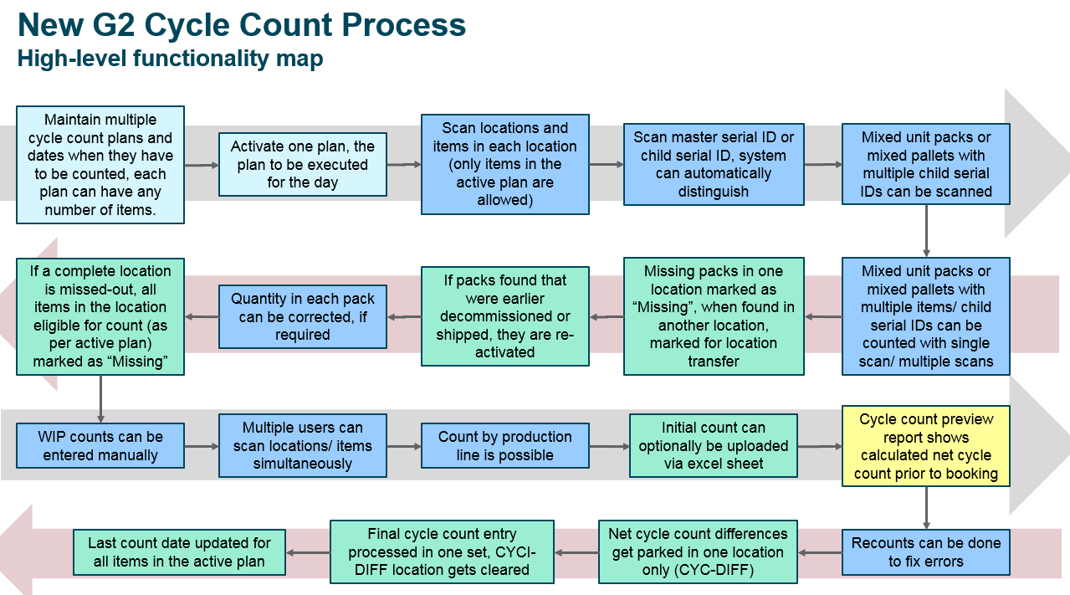

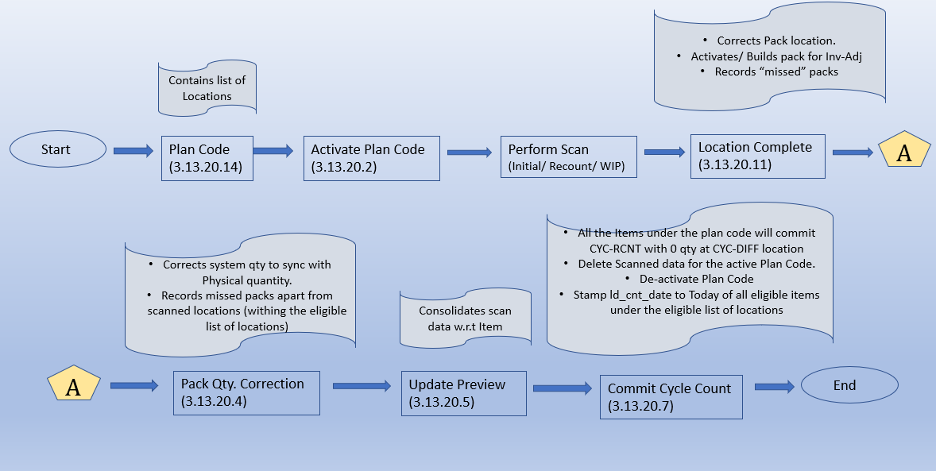

The AS transactions remain to be common for CC and RA.
Rack Audit counting in QAD consist of the following steps:
- RA (Rack Audit) plan is created in the system via maintenance program *RackAudit Plan Code Maintenance (3.13.20.14).
- Plan can be activated via 3.13.20.2 program. Only one plan can be activated at a time.
- Physical counting is done via scanning. Scanning process records results in QAD directly. All eligible locations must be counted. Every non-counted inventory location (within the eligible location) will be marked as Missed and written off.
- Online results/ progress of the counting can be checked in 3.13.20.12 browse.
- Location complete in AS solution can be done automatically after location is counted if Location Complete is given as “Yes”.
- 3.13.20.4 program must be run to correct qty in the “completed” locations. This program moves materials from/ to counted locations to CYC-DIFF location. Pack qty for serialized inventory and loose inventory are corrected. Missed serials from unscanned eligible list of locations of the active RA Plan code are identified at this stage.
- 3.13.20.5 Status update program must be run when all relevant locations are counted and corrected.
- Results on the counting with financial impact and tolerances can be seen in 3.13.20.6 browse. Results must be confirmed outside of the system by material manager/ plant controller/ plant manager if required.
- Recount may be initiated for some parts. Remember that Recount via AS deleted all the serials in the location and considers the scan afresh.
- Location complete (3.13.20.11 or via AS inbuilt Location complete)/ Pack qty correction (3.13.20.4) and Status update (3.13.20.5) should be run again after recounting. Results of the recount may be checked in 3.13.20.12 browse for detailed scan and 3.13.20.6 for Summarized information.
- 3.13.20.7 Processes and finalizes cycle counting results.
- Validation can be done with a transaction history program 3.21.2.

Creating a plan
Define the scope of the counting and limit the number of locations before starting RA process that will be available for counting. Plan for a single day can include several items from different product lines.
- RA Plan can be created directly in the system using 3.13.20.14 menu:
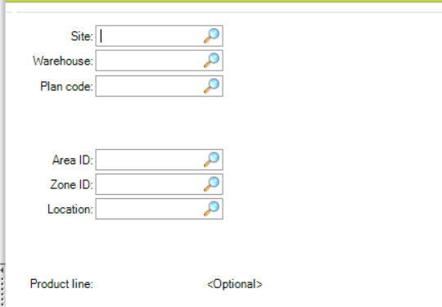
Include all locations which are to be made part of the RA plan code.
Either add location one after the other else just give Area ID or Zone ID alone to make all locations under Area or Zone part of the RA plan code.
Product line can be made part of the Plan code. It is optional. If Product line is applied, then the flag “Restricted by PL” will be marked as Yes.
The no. of product lines added are stamped to all the records in xccpl_mstr.
In case of RA, xccpl_mstr creates one record per location and every location will have the Product line stamped.
- Note:- RA does not have manual upload feature available.

- All plans (plan codes) in the system can be reviewed with 3.13.20.15 browse:
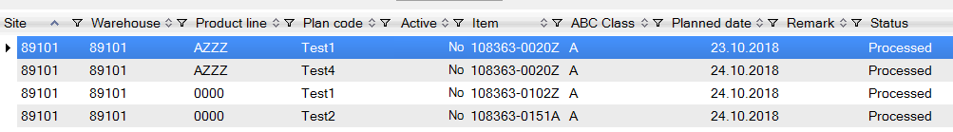
In the browse you can see what plans for what items are loaded in the system. Which plan is active and which plans are processed.

Activating the plan: 3.13.20.2
After you have your plan loaded in the system – you must activate the plan. Only non-processed plans can be activated.
Note: Plan cannot be modified after it is activated.
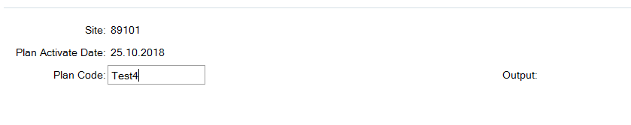
You can check the results in the output report or in 3.13.20.15 browse. As the plan code is activated the flag xccpl_status becomes Yes (can be seen in 3.13.20.15). As and when a plan code is activated the xccs_mstr record is created which can be seen in the browse 3.13.20.6. The xccs_mstr table creates Item records which have inventory in the eligible list of locations which are part of the active Plan code. When a RA Plan code is deactivated its respective records from xccs_mstr table are deleted and the corresponding xccpl_mstr records will have xccpl_status assigned back to No.

Counting and recording results

Note:- RA does not have manual upload feature available.
- Using AS solution for Serialized inventory:
- Open Initial Cycle Count program via scanner/ handheld
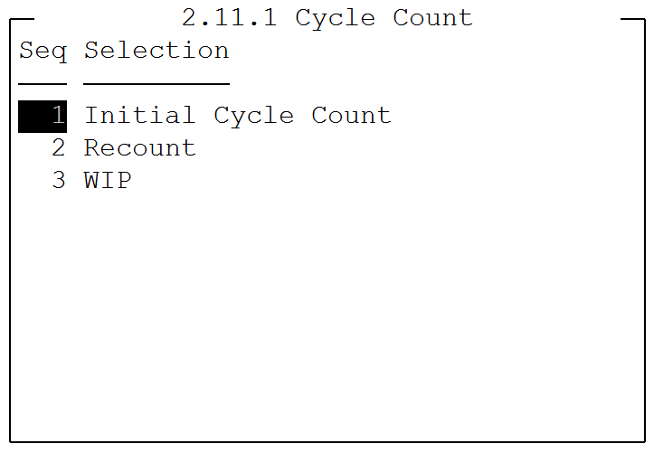
- Scan location ID (alternate location if applicable). F2 help provides the list if eligible locations of the active plan code.
- Scan Serial ID. Prefix “s”. F2 help provides the last level serials available under the scanned location. The records are created in the table (xccd_det). This table holds data of last level packs. Either child pack or unit pack.
If a scanned serial holds item which is not part of the plan code then the transaction prompts if the user wants to add the item and register the scan. If yes, then it will be considered else it will be skipped. Also while prompt the user checks if there is product line restriction. If so, then there will be a validation to check if the item in the serial belongs to the entitled product line. If yes , then it will be considered else No.
- Rescan a child pack/ unit pack in case of editing the quantity. If the last level pack is mixed, then an extra prompt for Item will appear to confirm the Item for which the quantity is being edited.
- Complete the location by pressing F10 in the scanner.
- Either move to the next location or mark the current location as complete via “Location Complete: Y”.
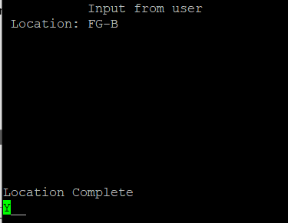

Note:-
- Initial and Recount AS transaction remains to be the same except for the following points mentioned below.
- Location once scanned and marked as complete (Location Complete: Y) via Initial count cannot be scanned again. To rescan a location, one must use Recount transaction.
- While performing Recount, all the serialized inventory records (in xccd_det) will be deleted from the respective scan location.
- A location can be scanned multiple times via Recount.

- Using AS solution for Loose inventory:
- Open WIP count program on your scanner/ handheld
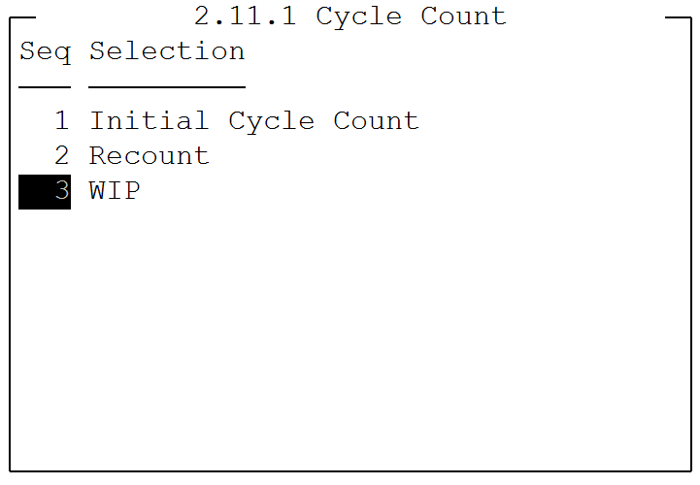
- Scan or type item number (with or without prefix)
- Scan or type location ID (not alternate ID)
- Optional: Enter lot information
- Optional: Enter Reference information
- Enter count results
- Complete the location by pressing F10 in the scanner
- Move to the next location

- Checking the results in CC details browse: 3.13.20.12
The current results (ongoing scan) of the counting can be seen in the browse 3.13.20.12.
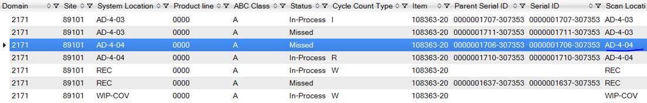

Location complete: 3.13.20.11
If AS solution location complete was not done for any reason – location complete process can be run manually with 3.13.20.11 program.
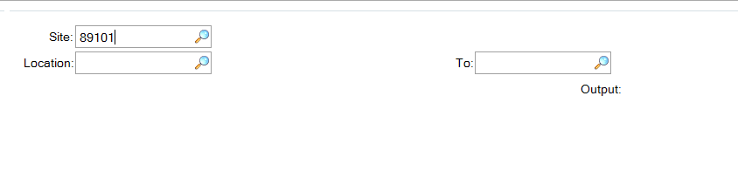
You may do this for one location, range of locations or all locations (by leaving locations fields blank) in the system.
The Location Complete handles the below activities:-
- Correct the serial’s system location with the scan location if found to be different.
- Activate a serial if found to be of stage “Inv-Adj” and populate the inventory in the scan location.
- Pull out the missed serials from the scan location(s).

Pack quantity correction: 3.13.20.4
This program moves all the identified differences in the completed locations from/ to CYC-DIFF location.
This includes correction of pack quantities.
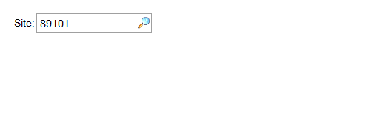
You just need to enter Site ID.
Also, this menu pulls out all the missed serialized and non-serialized inventory (holding eligible items) from the unscanned yet eligible locations of the active RA plan code.

Counting Status Update: 3.13.20.5
It is only possible to complete this step after all counting is done.
Site ID is the mandatory field.
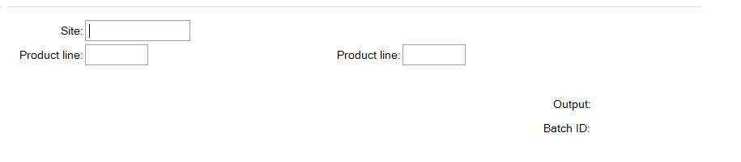
This menu helps the user to preview/ understand the impact if the plan code is committed via final menu 3.13.20.7. Also, it will stamp the xccd_det records as Processed (xccd_status), i.e., all the “In-process” records are converted to “Processed”. The status of records in xccs_mstr turns from blank to “In-process” (xccs_stat).

Reviewing counting results: 3.13.20.6
You can review the results of the couning at this stage using Status Browse 3.13.20.6
In this browse you can see if counting is in tolerance and what is a financial impact.
Use this report to get approval from Material Manager/ Plant Controller/ Plant Manager (as per BOS requirement)

Recounting and recording recounting results
- Using AS solution for Serialized inventory:
- Open Recount program via scanner/ handheld
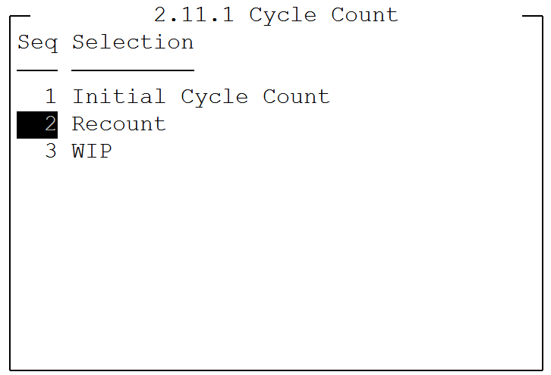
- Optional: scan or type product line
- Optional: scan or type (with prefix “p”) Item number
- Scan location ID (alternate location is taken)
- Scan all the serials for the “planned” items in this location
- Complete the location by pressing F10 in the scanner
- Move to the next location

- Using AS solution to recount Loose inventory:
- Open WIP count program on your scanner/ handheld
- Scan or type item number (with or without prefix)
- Scan or type location ID (not alternate ID)
- Optional: Enter lot information
- Optional: Enter Reference information
- Enter count results
- Complete the location by pressing F10 in the scanner
- Move to the next location

- Checking the results in CC details browse: 3.13.20.12
The current results of the recounting can be seen in the browse 3.13.20.12. Recounted Inventory have Cycle-Count R.

Updating Status after recounting:
To process differences found during recount process one must run programs
- 3.13.20.11 – Location complete (see above)
- 3.13.20.4 – Pack qty correction (see above)
- 3.13.20.5 – Status update (see above)
- 3.13.20.6 – Review the results in Status browse for final confirmation:

Processing cycle counting results: 3.13.20.7

After you are ready to process results of the counting – execute 3.13.20.7 program.
This program is generating CYC-RCNT transaction for all inventory that is in CYC-DIFF location.
It will also close the active plan and mark it as Processed in Plan Browse (3.13.20.15)
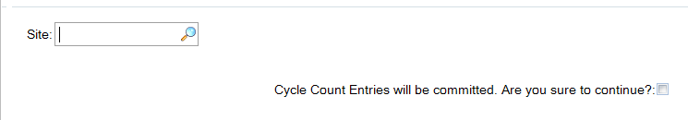
You need to confirm that you want to execute the transaction by checking the box.
This program performs the below activities:-
- Stamps count date (ld_cnt_date) as Today for all the eligible items (which are part of plan code) in all the eligible locations of the active RA plan code.
Note:- Does not stamp count date in in_cnt_date.
- Decommissions the missed serialized inventory and the transfers the loose inventory to the CYC-DIFF.
- Missed non-serialized inventory also is transferred to the CYC-DIFF.
- Generates CYC-RCNT transaction for all the inventory that is in CYC-DIFF location. Even if there is no inventory for an eligible item of the plan code, it does generate CYC-RCNT in the CYC-DIFF location with 0.
- Sends the complete detailed table records (seen in 3.13.20.12) as webpage output and deletes the table (xccd_det) records.
- Deactivates the plan code. xccpl_status = NO.
- Summary table is stamped as “Processed” (xccs_stat = “Processed”).

Checking counting results in Transaction History: 3.21.2

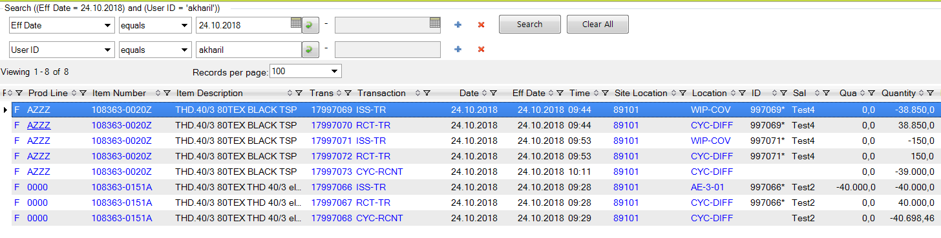
Recommended filters:
- Effective date: date of the counting
- User ID: global ID
- So/job: <Plan code>

*Location Check for RA Plan Code (3.13.20.16) :-

This is a standalone menu and can be run at any time.

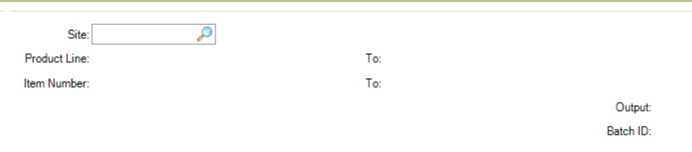

Provide Site. Product line and Item Number are optional.
The program traverses through all the items under the given criteria.
It checks the ld_cnt_date of the item under the given site. If all the ld_cnt_date fall withing the range of today to (today – pt_cyc_int) then the latest ld_cnt_date is picked and stamped to the in_cnt_date field.
If anyone of the ld_cnt_date is blank or ? then it skips such items and does nothing.

*Exclude Item from RA Plan Code (3.13.20.17) :-

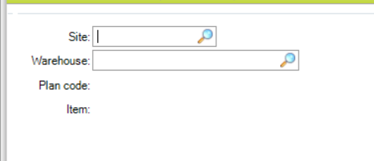
This feature is enabled for RA plan code only.
While performing RA plan code, user can have an Item removed from the Plan code which is found to be “Out of Tolerance”.
Site and Warehouse are mandatory fields. Plan code will get defaulted with the active RA plan code.

Enter Item which is to be removed from the plan code which is Out of Tolerance.
This Item will have all it occurrence removed from xccd_det and xccs_mstr.
If the item is part of any mixed serials, then it will not be allowed to get removed from the current active RA plan code.
While being removed there will be a CC plan code created automatically in the backend which can also be viewed via 3.13.20.3.
The scanned data (seen in 3.13.20.12) of the removed item is stored into usrw_wkfl table.
As and when items are removed from the plan code, they get added to the automatically created CC plan code. And also, the respective scanned data are added to the usrw_wkfl w.r.t the site/plan code/serial/item.

3.13.20.2 (*Cycle Count Plan Activation) :-

While activating above mentioned automatically created CC plan code which was replicated from an RA plan code the program prompts if the user wants to retain the scanned data from the previous RA plan code.
On Yes,
- All the data from the usrw_wkfl w.r.t the given plan code will be created in the xccd_det table
- xccpl_mstr will have xccpl_status: Yes,
- xccs_mstr will have all the items created for the plan code
- Delete the corresponding usrw_wkfl records of the plan code.

On No,
- It will just activate the plan code by xccpl_status as Yes,
- Create item records in xccs_mstr. It will not carry forward the scanned data from the previous plan code.

Miscellaneous Info:-

Records created in xccpl_mstr in case of RA plan code:-

Plan code | Location | Pod Line
RA1 | Loc1 | PL1, PL2 ..
RA1 | Loc2 | PL1, PL2 ..
RA1 | Loc3 | PL1, PL2 ..

Record creation in xccs_mstr(while activation) in case of RA plan code:-

Items pertaining to PL1 and PL2 only will get created in xccs_mstr while activation. In case of no product line applied then all items under the location will be considered.

Plan code | Location | Item Number | Pod Line
RA1 | Loc1 | Item1 | PL1, PL2 ..
RA1 | Loc1 | Item2 | PL1, PL2 ..
RA1 | Loc2 | Item3 | PL1, PL2 ..
RA1 | Loc2 | Item4 | PL1, PL2 ..
RA1 | Loc3 | Item5 | PL1, PL2 ..
RA1 | Loc3 | Item6 | PL1, PL2 ..

Data creation in xccd_det shown below:-

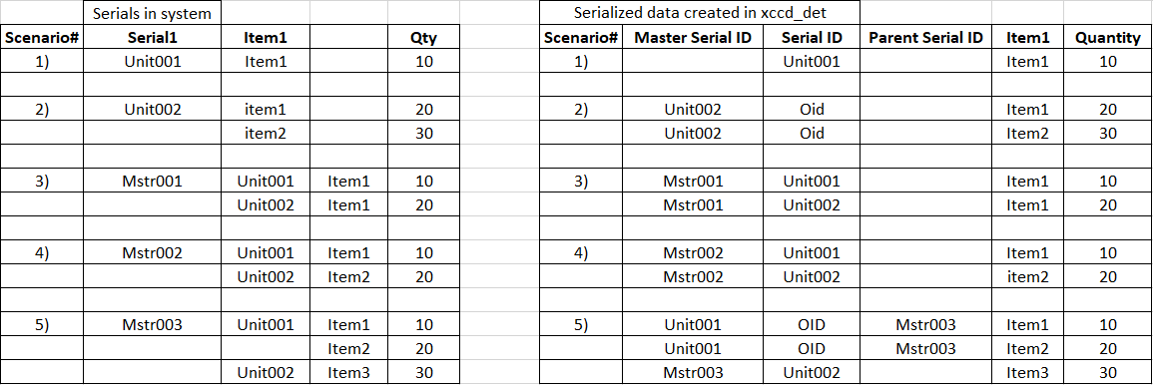

Status of customized tables during each stage:-

Tables Vs Stage | Scanning | Location Complete | Preview Update  (3.13.20.5) | Plan code commit  (3.13.20.7)
xccd_det (serialized)  (Initial/ Recount) | Pending | In-process | Processed | records deleted
xccd_det (non-serialized)  (WIP Count) | In-process | In-process | Processed | records deleted
xccs_mstr | - | - | In-process | Processed

